Minority Print Media and Diversity in North Carolina
GEOG 370 Term Project - Dustin Duong

Introduction

News outlets occupy a visible and significant niche in the contemporary media landscape. In the most basic sense, they act as gatekeepers of information. Decisions about what information to disseminate to the public, in what manner and with what intent are batted around in editorial budget meetings and considered on the ground by reporters. Since it is infeasible for any given member of the public to sort through all of the information that may or may not be relevant to their lives, it is necessary for them to look to media outlets to filter it for them and package it in palatable, understandable form. Because these filters are ultimately human, it would be impossible to remove all bias - whether implicit or explicit - from news media. Rather than undertake the task of eliminating bias altogether, which in many cases implies the removal of lived experience, emphasis should be placed on diversity and representation, both in individual newsrooms and in the media marketplace as a whole.

In 1979, the American Society of News Editors pledged that the proportion of racial and ethnic minorities in newsrooms would match that of the general population by the year 2000 (Arana). Thirty-nine years later, by the fall of 2018, the Columbia Journalism Review would issue a report about the “Decades of Failure” that the industry experienced since the lofty promises of the late 20th century. It offers a bleak picture of the contemporary newsroom, finding that only 17% of U.S. newsroom staff was nonwhite, compared to 37% of the U.S. population at large. Even more stark is a figure that suggests only 13% of newsroom leadership comprises minorities (Arana). In 2020 especially, as the nation faced significant social upheaval during the COVID-19 pandemic and critical movements around race, the journalism industry fell under intense scrutiny for its status quo. Writes researchers from the Oxford University Research Initiative in a study on the changing newsroom:

“Pressure has been building from audiences and from ethnic minority staff to ensure that journalists are more sensitive to the concerns of black and other minority groups – as well as to historical injustices.” (Cherubini et al, 14)

The study found that 42% of the respondents in an Oxford survey identified ethnic diversity as their topmost diversity priority in newsroom, over gender, economic and political diversity. There is a vested interest, then, in the pursuit of diverse newsroom staff. Not unlike in the realm of politics, a population can best be served by a representative population of news professionals.

Beyond the mainstream, however, a bulwark of minority interests stands in the loose collection of alternative media that occurs in the marketplace of ideas. Called “ethnic media” (or, in some cases, “minority media”), these are those publications that cater specifically to audiences of ethnic or racial minorities, immigrant and diasporic populations, and refugee communities in the United States. In many cases, these outlets are headed by members of the same communities themselves, and “challenge cultural stereotypes by providing more auspicious and diverse portrayals of minority groups” (Ramasubramanian, 1880). This condition arises, in part, from the presence of newsroom leaders and journalism professionals who represent the communities they serve in these minority media outlets.

Beyond the capability of these sources to focus on issues that are most relevant to these swaths of the population, and their ability to overcome cultural barriers (in many cases, this includes attention paid to the language barrier), a study in the International Journal of Communication finds more of a demonstrable, positive benefit among the Indian diasporic community when its members consume ethnic media as well as mainstream American media than those members who exclusively consume mainstream media (Ramasubramanian et al). One of the principal differences in this study from our analysis is its inclusion of transnational media, whereas ours focuses on local journalism. However, the general point concerning ethnic media as a whole follows the same conclusion. The researchers found that, among the Indian community in the United States, exposure to ethnic media improved self-esteem, ethnic pride, and ethnic performance (1889). Conversely, mainstream media sources often had negative effects on these three measures.

“...those individuals who rely on mainstream media as the main source of information about their in-group, there is a tendency toward self-stereotyping as evidenced by significant relationships with self-reported lower self-esteem.” (1889-1890)

All of this considered, what does this imply for North Carolina? The Census Bureau reports from the 2020 census that the state as a whole exhibits a diversity index - a concept that will be addressed in more detail in the “Methods” section - of 61.1%, up from 54.9% from the 2010 census (America Counts Staff). This indicates that the population is becoming more racially diverse as the proportion of the nonwhite minority increases in tandem with the decrease of the white majority proportion. This indicates a growing need for minority print media to serve the expanding minority population. This is certainly not limited to urban population centers, where there tends to be a greater volume of media outlets generally (Abernathy), increasing the . Particular attention should be paid to rural regions especially, as they are more prone to developing news deserts, a condition in which their communities have “ limited access to the sort of credible and comprehensive news and information” (Abernathy).

This, then, presents an important question:

Which counties in North Carolina exhibit the most need for minority
print media outlets that are as of yet not present?

Methods

Our state-level analysis of North Carolina identifying the county-based need for minority print media was predicated on a number of essential factors: the diversity index by county, geolocated instances of relevant publications, and the coverage zones of each of those publications. In addition, we needed a basic vector shapefile of all 100 counties of North Carolina represented as polygons. Drawing together these elements brings us closer to answering the objective and representing it on a map.

Simpson’s Diversity Index. This is rooted in what was originally an ecological concept, but has since been co-opted for other research purposes (Royal Society of Geography) and institutions like the Census Bureau for population statistics purposes. In the latter case, it is a value bounded between 0 and 1 used to determine the likelihood of two individuals of the same population chosen at random being of a different race, with a tendency toward 1 indicating a higher chance of selecting two individuals of different races (Jensen et al). At higher diversity indices, then, one can expect higher diversity within a population; the probability of selecting two people of the same racial identity decreases as the proportion of these differing racial groups increases.

The formula is as follows:

$D = 1 -\frac{ ∑ n(n-1)}{N(N-1)}$, where n is the number of individuals of a single racial identity and N is the whole population.

We preferred using Diversity Index as a metric to determine “need” because it offered a more holistic view of each county that fit for a relatively broad look at minority print media as a whole. Since we decided to accept any minority print media into consideration regardless of race, it would have painted an incomplete picture were we to represent counties by their proportion of any single race. Additionally, greater diversity would imply a need for a more diverse range of alternative media sources to accommodate the varied cultural makeup of an area.

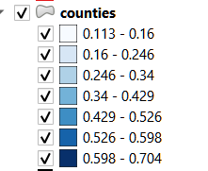
We sourced a public domain CSV dataset from one Mike Johnson, Jr. (2016) that included the diversity index and percentage of each major racial/ethnic classification: Black or African American alone; American Indian and Alaska Native alone; Asian alone; Native Hawaiian and Other Pacific Islander alone; Hispanic or Latino; White alone, not Hispanic or Latino; Two or More Races, for the year 2013 for every county in the United States. We narrowed the list by filtering out North Carolina’s counties, then exported a CSV file that included only these counties. In creating the join with the county name column from this CSV file and the county name column from the NC counties attribute table, it was necessary to edit the former so that the notation matched the latter’s for a successful join. Then, after each county polygon contained the data on its diversity index, we applied a graduated symbology to create 7 classes with Natural Breaks (Jenks) to differentiably display each county and emphasize the difference among them.

Figure 1. Graduated symbology using Natural Breaks.
Geolocated Instances of Minority Print Media Publications.

After each county was classified by its diversity index, we created another vector layer to lay points wherever an instance of a minority print media publication occurred, sourcing from the North Carolina Department of Administration’s public-facing directory of minority print media, as well as from a list of historical African American newspapers in North Carolina from the DigitalNC project, some of which were still active and did not appear on on the NCDOA website. We used their street addresses to create a new vector layer containing points to represent their locations in order to depict locality and concentration.

We opted to additionally display another level of crucial information via these vector points. Using a categorized symbology, we applied a different color dependent on which audiences they served. Referring to their websites, we drew from published or otherwise tangible declarations of intent to determine which minority community they sought as an audience rather, as often many publications will include statements to indicate what audience they seek to serve. These included: Asian, Black, Hispanic, Multicultural. In those cases where no such statement of intent could be found, we included an Unstated class, in the interest of avoiding presumption.

Coverage Zones. Another important consideration we addressed was that of “coverage zones,” since some publications report to serve a wider geographic audience than the county in which they are located. We referred to both the NCDOA website, which under most entries lists “Coverage,” as well to the respective publications’ websites to determine which counties fell into a reported coverage zone. Unlike with the above classification of vector points, we were able willing to draw implications about locations for publications that did not have a comprehensive list of covered countie. Though, we only extended it across the county in which they were located in order not to make undue assumptions about their operating capabilities or budgets, especially where that information was unavailable.

In the attribute table for each county, we added two columns: covered and covered_by. We used the former column as a basic boolean indicating true/false whether it fell into a coverage zone at all. The latter column was used to specify which publication(s), since some counties fell into multiple coverage zones. We opted to Select by Value each county with a true value in its covered column, then exported the selected features to a new layer and displayed it with a single-symbol red outline to visualize coverage areas.

“Need” Selection. To follow the creation of a visually representative map, we used Select by Expression to isolate counties that had a diversity index over 0.5, which within its 0 to 1 bounds indicates a tendency toward being more diverse or those counties with a proportional white population under 50% in order to include outliers counties like Bertie that demonstrated low diversity because of a high population of minorities, which meant they were excluded from diversity index > 0.5 despite having conditions that would not preclude them from being in need of minority print media. We used the following expression to accomplish this: “diversityindex_NC_Diveresity-Index”>0.5 OR “diversityindex_NC_White alone, not Hispanic or Latino, percent, 2013”<50.

Then, keeping the same features selected and using Select by Location, we selected features from our polygon layers that intersect or are within the outlined polygon layers indicating covered, and removed the result from our selection, leaving us with our results: those that had high diversity OR a majority nonwhite population AND did not fall in a coverage zone by minority print media.

Results
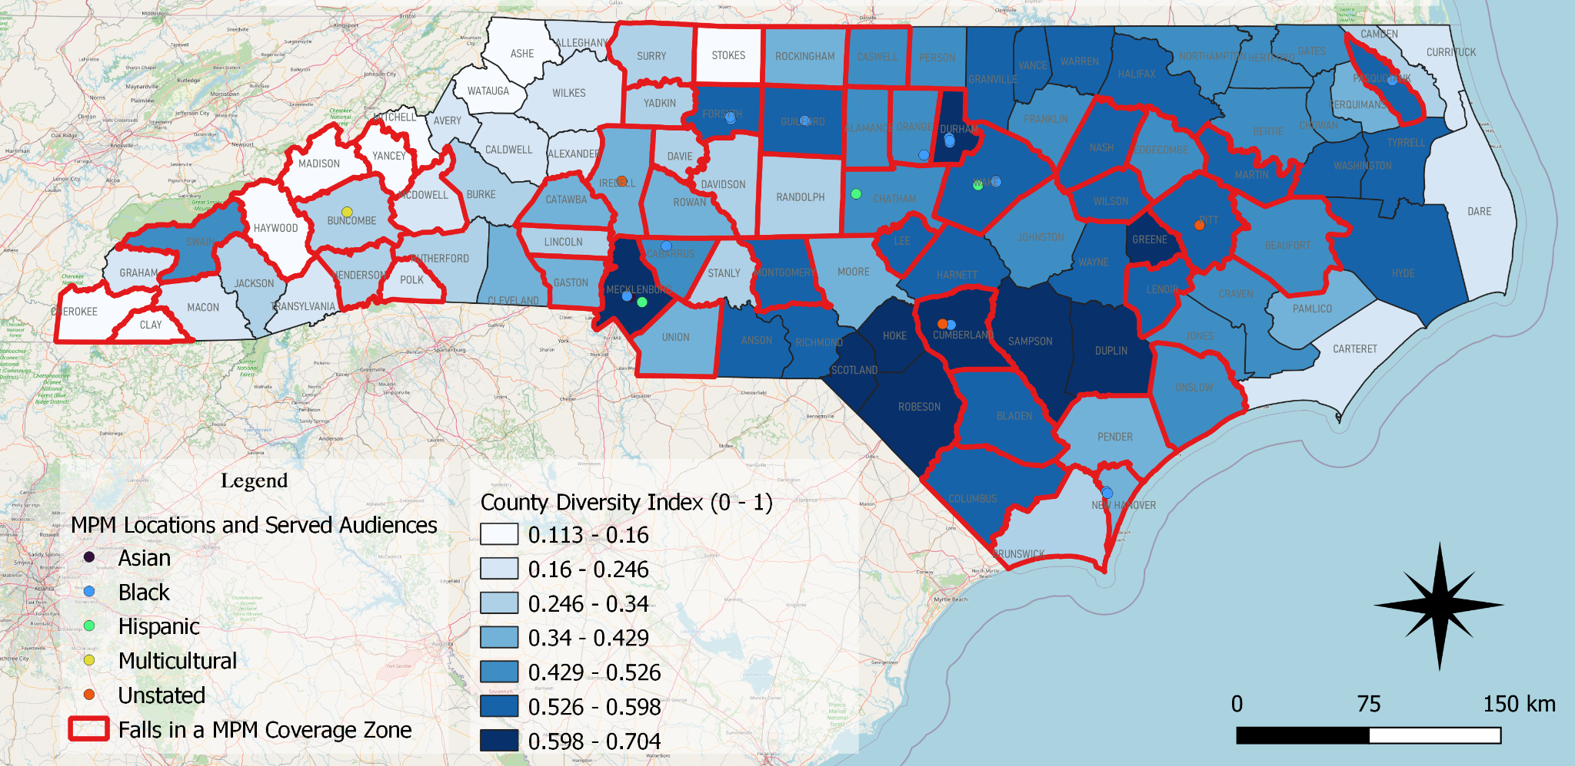
Figure 2. The finalized map combines all elements in a visually presentable manner.

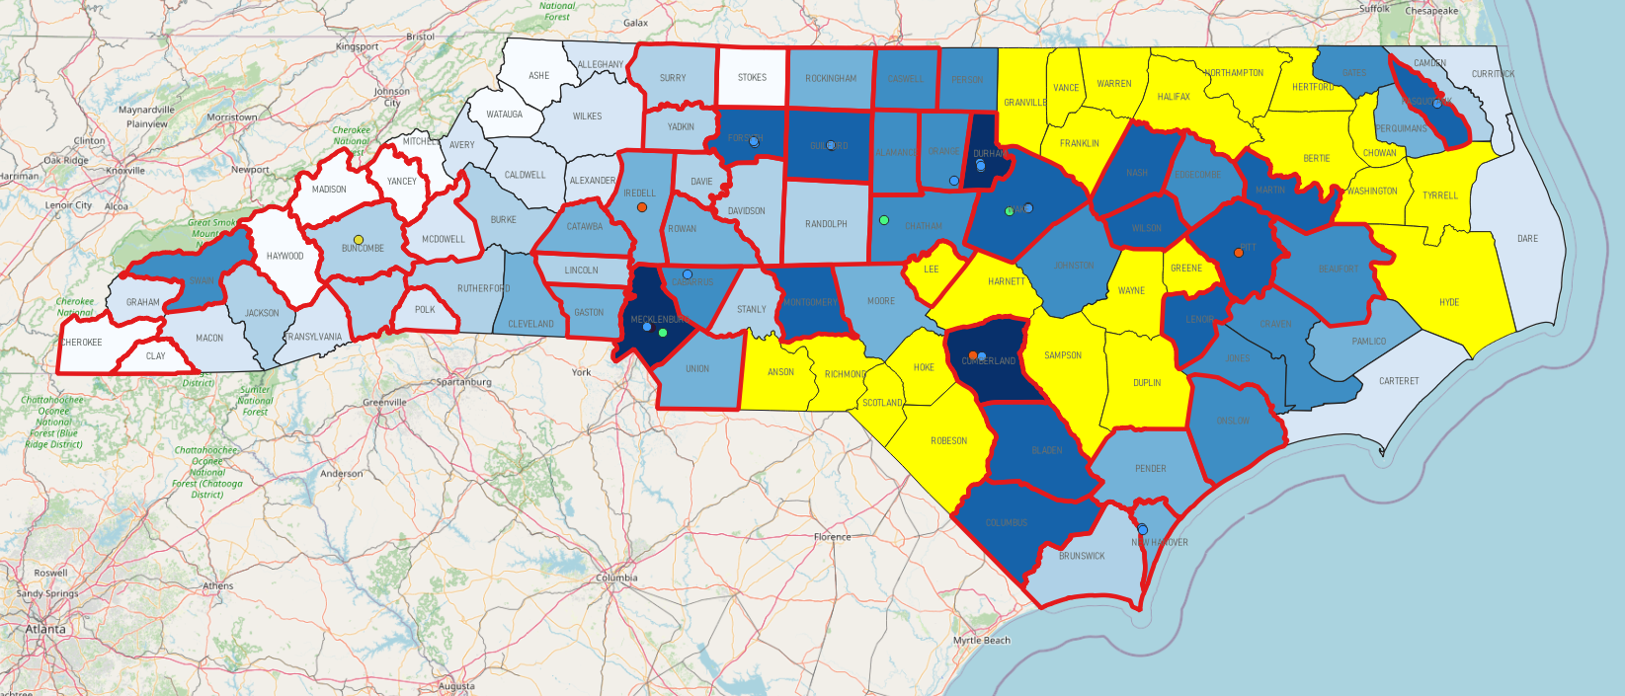
Figure 3. A selection of counties which demonstrate the most need for a currently absent minority print media landscape.

These demonstrate high diversity OR a high nonwhite population AND do not fall in a coverage zone for an existing minority print media publication.

Our findings indicated: 23/45 (~51%) counties with high diversity or high nonwhite population did not fall into a coverage zone and are in need of minority print media; thus, 23/100 (23%) of North Carolina counties are in need of minority print media. These include:

ANSON
ALLEGHANY
BERTIE
CHOWAN
DUPLIN
FRANKLIN
GRANVILLE
GREENE
HALIFAX
HARNETT
HERTFORD
HOKE
HIDE
LEE
NORTHAMPTON
RICHMOND
ROBESON
SAMPSON
SCOTLAND
TYRELL
VANCE
WARREN
WASHINGTON
WAYNE

Discussion

The most important element of our results lies in the collection of in-need counties. These are counties that lack representation of minority groups that are otherwise under- or misrepresented in the mainstream media, and which lack the alternative media to correct it (judging by the results of our analysis). Hoke, Robeson, and Scotland counties, for example, fall in the tribal service area of the Lumbee (Lumbee Tribe of North Carolina), in a state wherein there is also a startling lack of Indigenous-focused publications that are publicly listed or identified by the government. Or take the examples of Bertie, Halifax, Hertford, Northampton, Vance, and Warren counties, which exhibit a Black population of over 50%; Bertie has an over 60% Black population, per the Johnson dataset. Duplin, similarly, has the highest internal proportional Hispanic population of any county.

One of the largest difficulties in completing this analysis was the limited, piecewise documentation of minority print media publications. The NCDOA website was by no means exhaustive, and the DigitalNC list included archaic, inactive papers. What’s more, further research after the creation of this map revealed unlisted Hispanic media. It’s possible there are many more instances of minority print media that are somewhat inaccessible or unknown.

These counties are, ultimately, blindspots for the news media - places where minority audiences, particularly in rural counties, which seem to exhibit fewer instances of minority print media, are not represented by alternative media. These are areas which warrant increased attention and coverage by existing media outlets, or investment in the creation of journalism/news-gathering programs within. Community journalism is where change starts.
References
Abernathy, Penelope Muse. “THE EXPANDING NEWS DESERT.” The Expanding News Desert. UNC Hussman School of Journalism and Media, December 11, 2020. https://www.usnewsdeserts.com/states/north-carolina/#1536357227273-1fcd2118-6dc6.
Bennett College, Cape Fear Museum, Chapel Hill Historical Society, Charlotte Mecklenburg Library, Dudley Alumni Association, Durham County Library, Elizabeth City State University, et al. “African-American Newspapers in North Carolina.” DigitalNC. North Carolina Digital Heritage Center, 2021. https://www.digitalnc.org/exhibits/african-american-newspapers-in-nc/.
Cherubini, F, N Newman, and R Nielsen. 2020. “Changing Newsrooms 2020: Addressing Diversity and Nurturing Talent at a Time of Unprecedented Change.” Reuters Institute for the Study of Journalism.
Arana, Gabriel. “Decades of Failure.” CJR.org. Columbia Journalism Review, 2018. https://www.cjr.org/special_report/race-ethnicity-newsrooms-data.php.
Jensen, Eric, Nicholas Jones, Kimberly Orozco, Lauren Medina, Marc Perry, Ben Bolender, and Karen Battle. “Measuring Racial and Ethnic Diversity for the 2020 Census.” The United States Census Bureau. United States Government, October 14, 2021. https://www.census.gov/newsroom/blogs/random-samplings/2021/08/measuring-racial-ethnic-diversity-2020-census.html.
Johnson, Mike. “Diversity Index of US Counties - Simpson Diversity Index to Quantify Racial Diversity of US Counties,” 2016.
NC DOA. “North Carolina Department of Administration.” Minority Print Media. North Carolina Department of Administration, 2021. https://ncadmin.nc.gov/businesses/historically-underutilized-businesses-hub/business-resources/minority-print-media.
NC Office of State Budget and Management. “Population by Race/Ethnicity (ACS) Shapefile.” North Carolina: North Carolina, 2021.
Royal Geographical Society. “4G – A Guide to Simpson’s Diversity Index.” The Royal Geographical Society (with IBG). Institute of British Geographers, 2021. https://www.rgs.org/CMSPages/GetFile.aspx?nodeguid=018f17c3-a1af-4c72-abf2-4cb0614da9f8&lang=en-GB.

